**ASSIGNMENT 3**

|  |  |
| --- | --- |
| **ROLL NUMBER** | 2019503059 |
| **NAME** | Vignesh Siva P |
| **TEAM ID** | PNT2022TMID35705 |

1. **Create a Bucket in IBM Object Storage.**

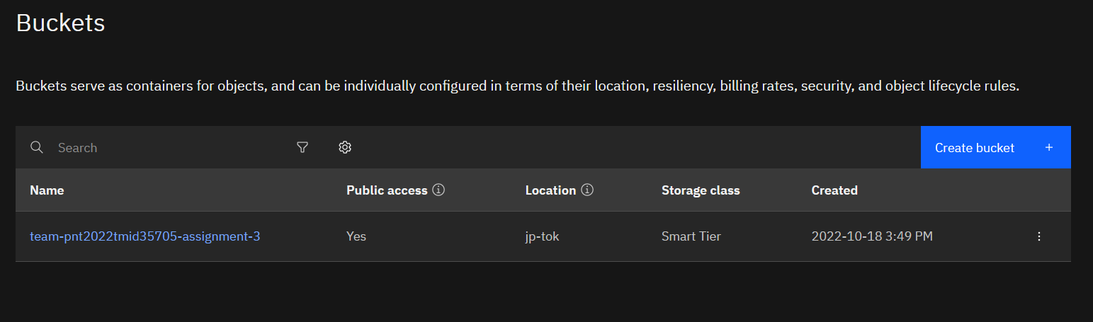

1. **Upload 5 images to IBM Object Storage Bucket and make it public. Create a HTML page and display these 5 images.**

**SOURCE CODE**

<!DOCTYPE html>

<html lang="en">

<head>

    <meta charset="UTF-8">

    <meta http-equiv="X-UA-Compatible" content="IE=edge">

    <meta name="viewport" content="width=device-width, initial-scale=1.0">

    <title>Gallary</title>

    <link rel="stylesheet" href="style.css">

</head>

<body>

    <div class="container">

        <h1>Image Gallary</h1>

        <div class="wrapper">

            <img src="https://team-pnt2022tmid35705-assignment-3.s3.jp-tok.cloud-object-storage.appdomain.cloud/kratos1.jpg" alt="Image 1">

            <img src="https://team-pnt2022tmid35705-assignment-3.s3.jp-tok.cloud-object-storage.appdomain.cloud/kratos2.jpg" alt="Image 2">

            <img src="https://team-pnt2022tmid35705-assignment-3.s3.jp-tok.cloud-object-storage.appdomain.cloud/kratos3.jpg" alt="Image 3">

            <img src="https://team-pnt2022tmid35705-assignment-3.s3.jp-tok.cloud-object-storage.appdomain.cloud/kratos4.jpg" alt="Image 4">

            <img src="https://team-pnt2022tmid35705-assignment-3.s3.jp-tok.cloud-object-storage.appdomain.cloud/mustanggt.jpg" alt="Image 5>

        </div>

    </div>

</body>

</html>

**OUTPUT**

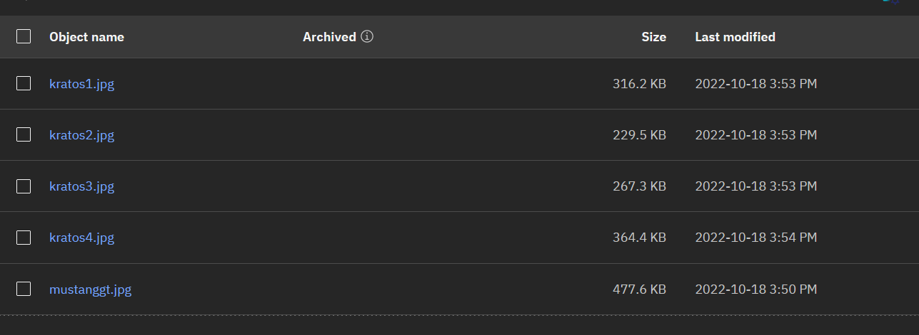

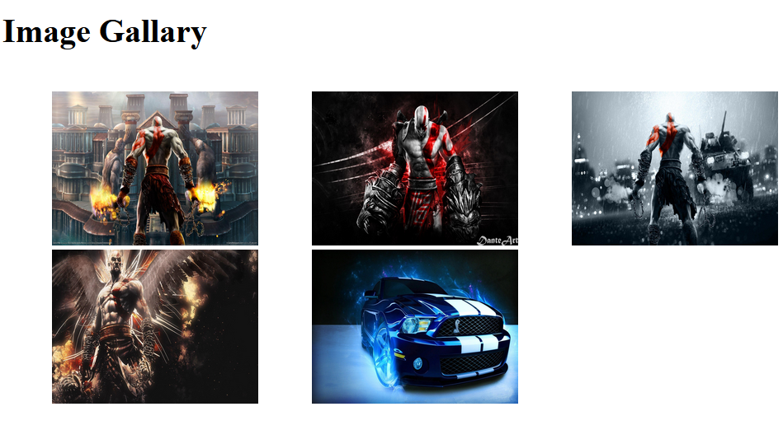

1. **Upload a CSS file to IBM Object Storage Bucket and use it on a HTML page.**

**SOURCE CODE**

**index.html**

<!DOCTYPE html>

<html lang="en">

<head>

    <meta charset="UTF-8">

    <meta http-equiv="X-UA-Compatible" content="IE=edge">

    <meta name="viewport" content="width=device-width, initial-scale=1.0">

    <title>Image Gallary</title>

    <link rel="stylesheet" href="https://team-pnt2022tmid35705-assignment-3.s3.jp-tok.cloud-object-storage.appdomain.cloud/style.css">

</head>

<body>

    <div class="container">

        <h1>Image Gallary</h1>

        <div class="wrapper">

            <img src="https://team-pnt2022tmid35705-assignment-3.s3.jp-tok.cloud-object-storage.appdomain.cloud/kratos1.jpg" alt="Image 1">

            <img src="https://team-pnt2022tmid35705-assignment-3.s3.jp-tok.cloud-object-storage.appdomain.cloud/kratos2.jpg" alt="Image 2">

            <img src="https://team-pnt2022tmid35705-assignment-3.s3.jp-tok.cloud-object-storage.appdomain.cloud/kratos3.jpg" alt="Image 3">

            <img src="https://team-pnt2022tmid35705-assignment-3.s3.jp-tok.cloud-object-storage.appdomain.cloud/kratos4.jpg" alt="Image 4">

            <img src="https://team-pnt2022tmid35705-assignment-3.s3.jp-tok.cloud-object-storage.appdomain.cloud/mustanggt.jpg" alt="Image 5>

        </div>

    </div>

</body>

</html>

**style.css**

https://team-pnt2022tmid35705-assignment-3.s3.jp-tok.cloud-object-storage.appdomain.cloud/style.css

*{

margin: 0;

padding: 0;

box-sizing: border-box;

font-family: 'Segoe UI', Tahoma, Geneva, Verdana, sans-serif;

}

.container {

width: 70%;

margin: 2rem auto;

}

.container h1 {

margin-bottom: 2rem;

}

.container .wrapper {

display: grid;

grid-template-columns: 1fr 1fr 1fr;

gap: 2rem;

}

.container .wrapper img {

width: 100%;

}

**OUTPUT**

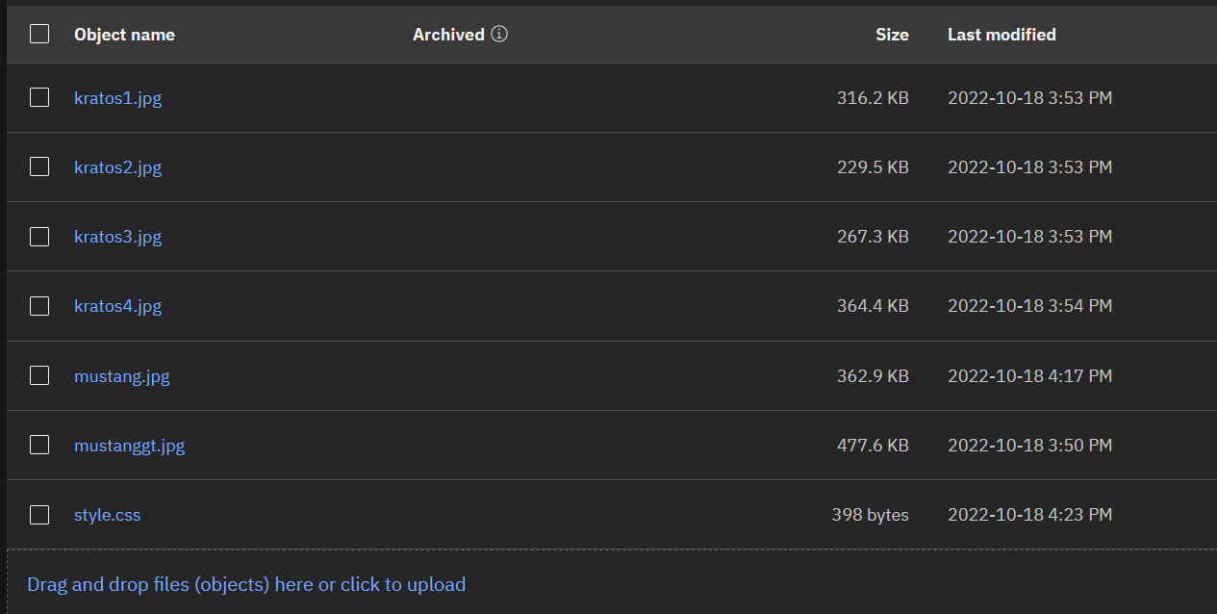

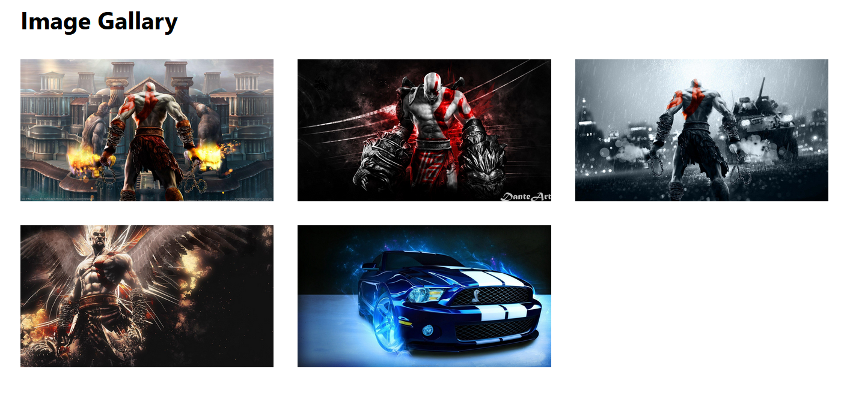

1. **Design a chat bot using IBM Watson for hospital**

https://web-chat.global.assistant.watson.appdomain.cloud/preview.html?backgroundImageURL=https%3A%2F%2Fau-syd.assistant.watson.cloud.ibm.com%2Fpublic%2Fimages%2Fupx-d6b3d761-5481-458f-8524-5f706be94088%3A%3Abc41935c-b25c-4858-b7a5-6e451d33bd90&integrationID=3a54966b-754b-4b5f-952d-91f3799eb0da&region=au-syd&serviceInstanceID=d6b3d761-5481-458f-8524-5f706be94088

**Output:**

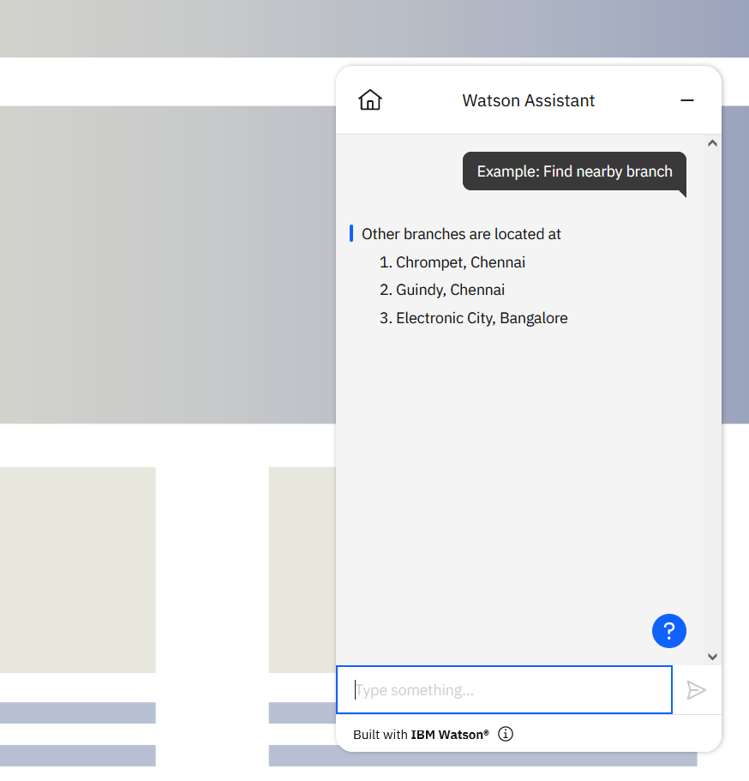

1. **Create a Watson assistant with 10 steps and 3 conditions and load that in HTML page**

**SOURCE CODE**

<!DOCTYPE html>

<html lang="en">

<head>

    <meta charset="UTF-8">

    <meta http-equiv="X-UA-Compatible" content="IE=edge">

    <meta name="viewport" content="width=device-width, initial-scale=1.0">

    <title>Hospital Bot</title>

</head>

<body>

    <script>

        window.watsonAssistantChatOptions = {

          integrationID: "3a54966b-754b-4b5f-952d-91f3799eb0da", // The ID of this integration.

          region: "au-syd", // The region your integration is hosted in.

          serviceInstanceID: "d6b3d761-5481-458f-8524-5f706be94088", // The ID of your service instance.

          onLoad: function(instance) { instance.render(); }

        };

        setTimeout(function(){

          const t=document.createElement('script');

          t.src="https://web-chat.global.assistant.watson.appdomain.cloud/versions/" + (window.watsonAssistantChatOptions.clientVersion || 'latest') + "/WatsonAssistantChatEntry.js";

          document.head.appendChild(t);

        });

      </script>

</body>

</html>

**OUTPUT**

